US-MA- Projectile Points of New England

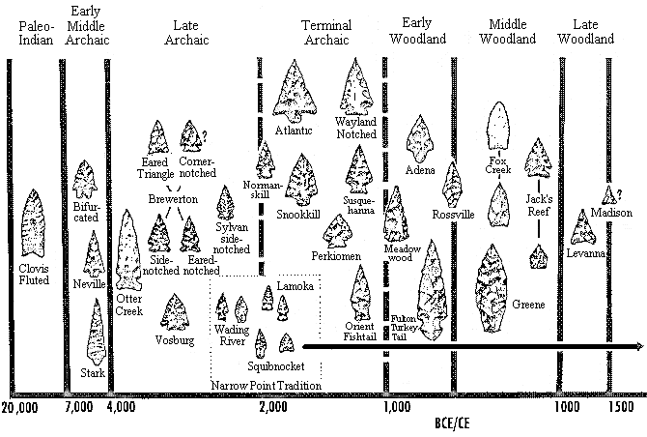

Projectile Points of New England